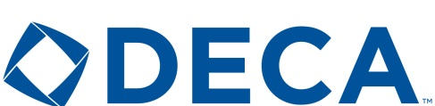 Minot High School 1100 11th Ave. SW Minot, ND 58701
Sponsorship Donation Form
Yes, I would like to support the Minot High DECA chapter with a donation of $
Business Name
Individual’s Name:
Address
City: State Zip Code: Phone:
Banner Recognition:
Businesses that sponsor students and/or the Minot High DECA chapter may elect to be recognized on our store banner. If you choose to do so, please email a logo for us to add to our banner at magimarket@gmail.com by May 01, 2019
Web Site Recognition Preference:
Businesses that sponsor students and/or the Minot High DECA chapter may elect to be recognized on our website found at http://www.marketingmps.com/sponsors.html.
No, while I am donating, I do not want to be recognized on your website
Yes I would like to be added to your web site
If yes, we will add the Business name, the individual’s name, or both in recognition for your sponsorship. See our examples below and enter exactly how you would like this added to our page.
Examples: James Johnson, XYZ Construction
I would like recognition shown as follows:

^{signature} ^{date}

